
University of Rwanda
College of Science and Technology
School of ICT
Department of Computer and Software Engineering
Academic year: 2025 – 2026
Date: On Friday, February 6th, 2026
Group Members:
No | Names | Registration Number
1 | Fabrice NDAYISABA | 223008047
2 | Silas HAKUZWIMANA | 223001019
Module: Mobile Application Systems and Design
Dart Programming Lab 1 Report

Table of Contents

Table of Figures ii
Dart Programming Lab 1 – Screenshots and Outputs 1
PART I: Functions 1
Q1) Functions – Welcome Message 1
Q2) Displays: “Welcome to school system” 1
Q3) Functions – Create Teacher 1
Part II: Constructors and classes 1
Q4. Classes – Student Constructor 1
Q5. Object Usage – Student Object 1
PART III: Inheritance 2
Q6. 2
Q7. 2
Part IV: Interfaces 2
Q8. Interfaces – Registrable 2
Q9. Interfaces – Student RegisterCourse 2
Part V: Mixins 2
Q10. Mixins – AttendanceMixin 2
Q11. Mixins Applied – Mark Attendance 2
Part VI: Collections 2
Q12. 2
Q13. 3
Part VII: Anonymous and Arrow functions 3
Q14. Anonymous Functions – Print Student Names 3
Q15. 3
Part VIII: Asynchronous Programming 3
Q16. Async Functions – Load Students 3
Q17. Async in Main – Await Students 4
Part IX: Integration Challenge 4
Q18. Integration Challenge – Mixins & Inheritance 4
Q19. Mixins – NotificationMixin 4
Q20.Learning Dart & Flutter 4

Table of Figures
Figure 1: Welcome Message 1
Figure 2: Create student 1
Figure 3: create teacher 1
Figure 4: object 1
Figure 5: inheritance 2
Figure 6: Mixin applied 2
Figure 7: display students 3
Figure 8: Anonymous and arrow functions 3
Figure 9: Loading students 4
Figure 10: Demonstration video 4
Figure 11: NotificationMixin 4

Dart Programming Lab 1 – Screenshots and Outputs

PART I: Functions

Q1) Functions – Welcome Message
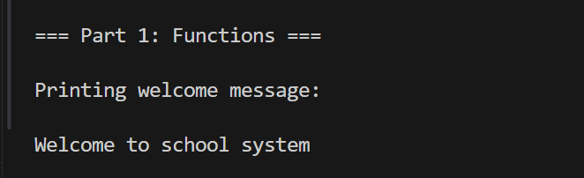
Figure 1: Welcome Message
Displays: “Welcome to school system”

Q2) Displays: “Welcome to school system”
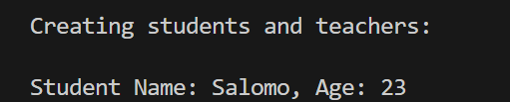
Figure 2: Create student
Displays student name and age, e.g., “Student Name: Salomo, Age: 23”

Q3) Functions – Create Teacher
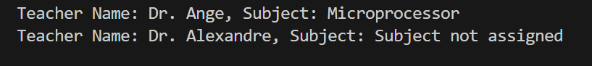
Figure 3: create teacher
Displays teacher name and subject; optional subject shows “Subject not assigned”

Part II: Constructors and classes

Q4. Classes – Student Constructor
No output

Q5. Object Usage – Student Object
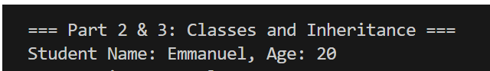
Figure 4: object

PART III: Inheritance

Q6.

Inheritance – Person Class
No output directly, only class definition

Q7.

Inheritance – Student Introduce
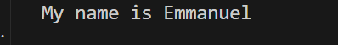
Figure 5: inheritance
Displays: “My name is Emmanuel”

Part IV: Interfaces

Q8. Interfaces – Registrable
No output directly; only abstract class definition

Q9. Interfaces – Student RegisterCourse
No output directly.

Part V: Mixins

Q10. Mixins – AttendanceMixin
No output; defines attendance counter and function

Q11. Mixins Applied – Mark Attendance
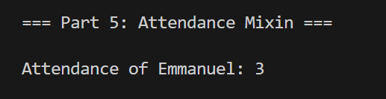
Figure 6: Mixin applied
Displays: “Attendance of Emmanuel: 3”

Part VI: Collections

Q12.

Collections – List of Students
Displays all students in list with name and age

Q13.
Collections – Map of Students
Displays student IDs and names from the map
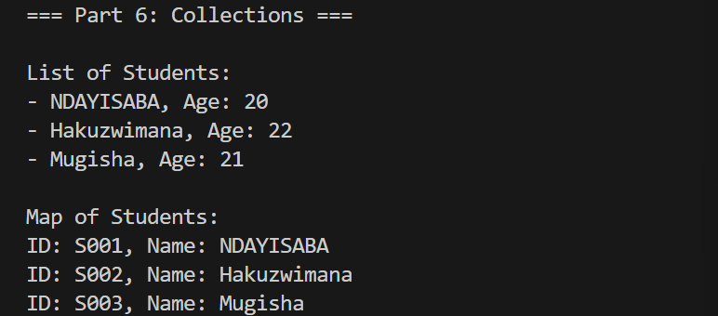
Figure 7: display students

Part VII: Anonymous and Arrow functions

Q14. Anonymous Functions – Print Student Names
Prints student names using anonymous function

Q15.

Arrow Functions – Greeting
Prints greeting message, e.g., “Good morning, Fabrice! Welcome to our school system.”

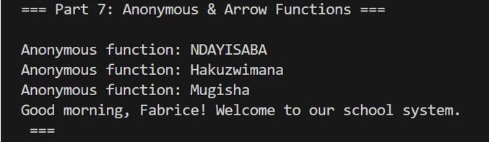
Figure 8: Anonymous and arrow functions

Part VIII: Asynchronous Programming

Q16. Async Functions – Load Students
Loading students...
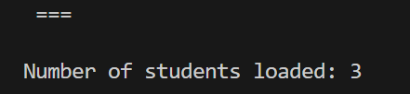
Figure 9: Loading students

Q17. Async in Main – Await Students
Already included in Q16 output
Video demonstration:
Click here to see the video
Figure 10: Demonstration video

Part IX: Integration Challenge

Q18. Integration Challenge – Mixins & Inheritance
No code output; handwritten summary available from scanned document.

Q19. Mixins – NotificationMixin
Output:
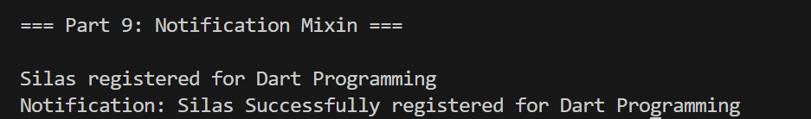
Figure 11: NotificationMixin

Q20.Learning Dart & Flutter
No output; handwritten summary available from scanned

